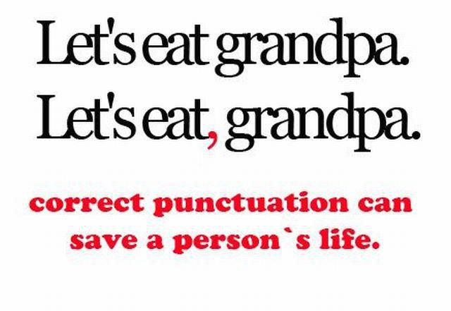
GRAMMAR GEEKS OVERVIEW

One of the important areas about learning in the language arts is developing literacy skills that will help you enhance the clarity and artistry of communication.

Improving the thoughtfulness, effectiveness and correctness of communication is what this Grammar Geeks Task is all about.

You will have an opportunity to:
- Set personal language goals
- Work collaboratively
- Research a specific area of language conventions
- Create a multi-media product
- Teach your audience about what you learned and created

